The map below is for Arnold car rider morning drop-off only (7:30-7:45).
Afternoon pick-up is in the front of Arnold.
Thanks!
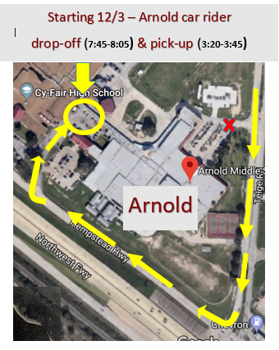
Arnold Car Rider Morning Drop-off
between 7:30-7:45

